**INF10002 – Database analysis and design**

**HEALTHCARE DATABASE PROJECT**

StuName: Ngo Minh Tan

StuID: 102953672

In this project, I had build a simple Healthcare database to monitor simply a medical hospital. In this case, I only focus and work on 1 hospital called Bạch Mai Hospital therefore only 1 data had been inserted into BENHVIEN table.

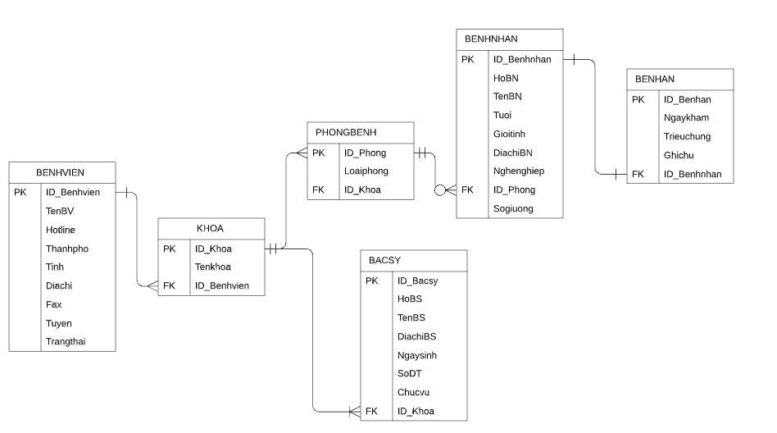

1. **Design ERD**

|  |  |  |
| --- | --- | --- |
| Entity | Attribute | Primary Key |
| BENHVIEN | ID_Benhvien, TenBV, Hotline, Thanhpho, Tinh, Diachi, Fax, Tuyen, Trangthai | ID_Benhvien |
| KHOA | ID_Khoa, Tenkhoa | ID_Khoa |
| PHONGBENH | ID_Phong, Loaiphong | ID_Phong |
| BACSY | ID_Bacsy, HoBS, TenBS, DiachiBS, Ngaysinh, SoDT, Chucvu | ID_Bacsy |
| BENHNHAN | ID_Benhnhan, HoBN, TenBN, Tuoi, Gioitinh, DiachiBN, Nghenghiep, Sogiuong | ID_Benhnhan |
| BENHAN | ID_Benhan, Ngaykham, Trieuchung, Ghichu | ID_Benhan |



1. **Relationship**

A Hospital (Benhvien) can have many Faculties (Khoa)

1 Faculty can have many doctors (Bac sy) working

1 Faculty also have many hospital rooms (Phòng bệnh)

1 hospital room can have 0 or many patients on that

1 Patient from a faculty can have one and only 1 medical record (Bệnh án)

1. **Relational schema**

BENHVIEN (ID_Benhvien, TenBV, Hotline, Thanhpho, Tinh, Diachi, Fax, Tuyen, Trangthai)

PK: ID_Benhvien

KHOA (ID_Khoa, Tenkhoa)

PK: ID_Khoa

FK: ID_Benhvien references BENHVIEN

PHONGBENH (ID_Phong, Loaiphong)

PK: ID_Phong

FK: ID_Khoa references KHOA

BACSY (ID_Bacsy, HoBS, TenBS, DiachiBS, Ngaysinh, SoDT, Chucvu)

PK: ID_Bacsy

FK: ID_Khoa references KHOA

BENHNHAN (ID_Benhnhan, HoBN, TenBN, Tuoi, Gioitinh, DiachiBN, Nghenghiep, Sogiuong)

PK: ID_Benhnhan

FK: ID_Phong references PHONGBENH

BENHAN (ID_Benhan, Ngaykham, Trieuchung, Ghichu)

PK: ID_Benhan

FK: ID_Benhnhan references BENHNHAN

1. **Raw data design**















1. Web function

* A connection between SQL Server and Visual Studio has been created as a form on the website. Data get from SQL statements will be displayed on this website to enable users view the information.
* 